`

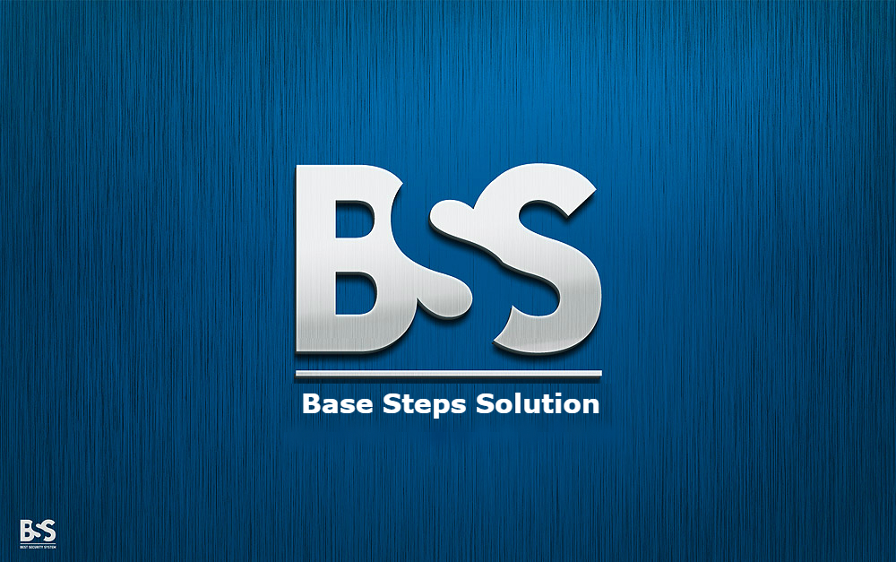

Software Process Life Cycle

Van Lang Admissions

# Revision Table

|  |  |  |  |
| --- | --- | --- | --- |
| Author | Date | Reason for changes | Version |
| Khoi Nguyen | 22/10/2016 | Template | 1.0 |
|  |  |  |  |

Table of Contents

Revision Table 1

1. INTRODUCTION 3

1.1. Purpose 3

1.2. Audience 3

2. Process 3

2.1. Process flow 3

2.2. Activities 3

2.3. Roles and Responsibility 3

2.4. Process Decision 3

# INTRODUCTION

## Purpose

The overall objective of a Software Process Lifecycle is

## Audience

The intended audience of the CM Plan is

|  |  |
| --- | --- |
| Intended Audience | Description |
|  |  |
|  |  |
|  |  |
|  |  |

# Process

## Process flow

## Activities

## Roles and Responsibility

## Process Decision